**Task-1: Scan your local network for open ports**

**Step 1:**

Installing Nmap in system using command

**“sudo apt update && sudo apt install nmap”**

**Step-2:**

Finding Local IP range and system IP address using command

**“ifconfig”**

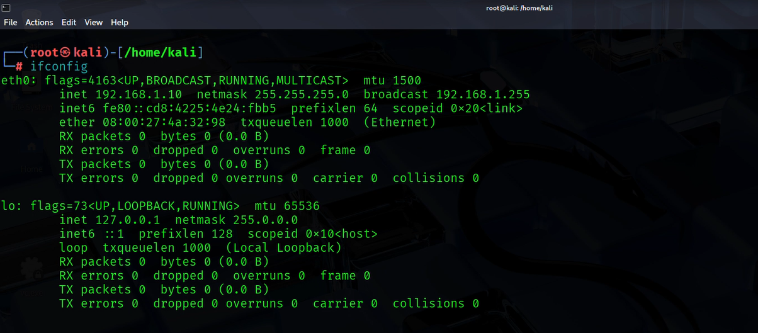

**Step-3:**

Run TCP SYN Scan

The command used to show the active hosts and their open ports.

**“nmap -sS 192.168.1.0/24”**

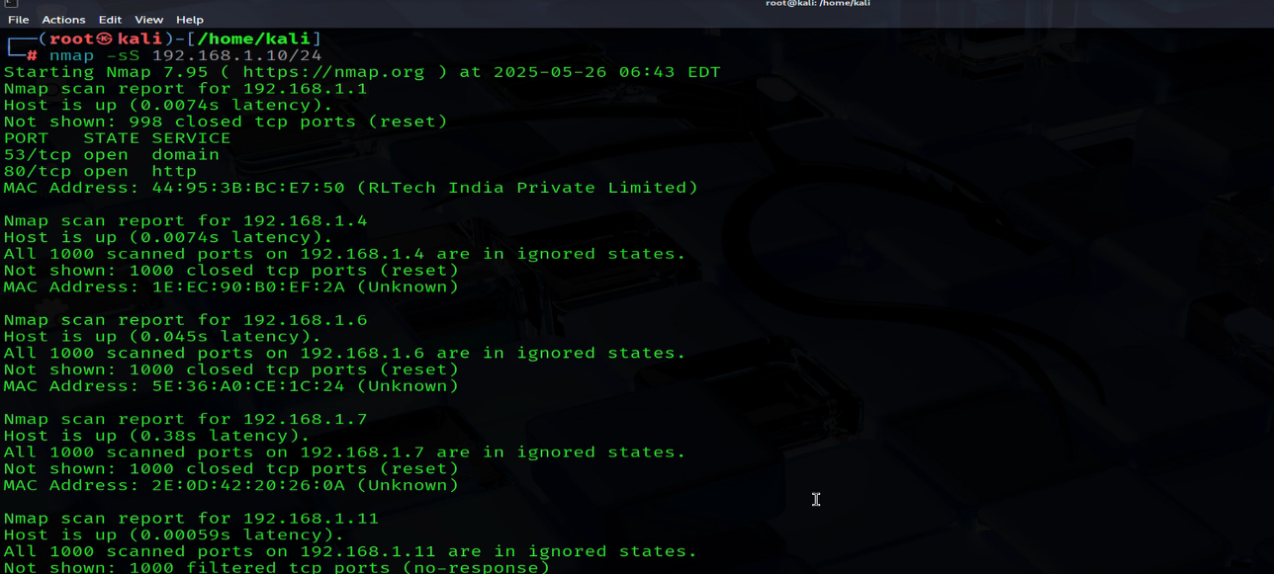

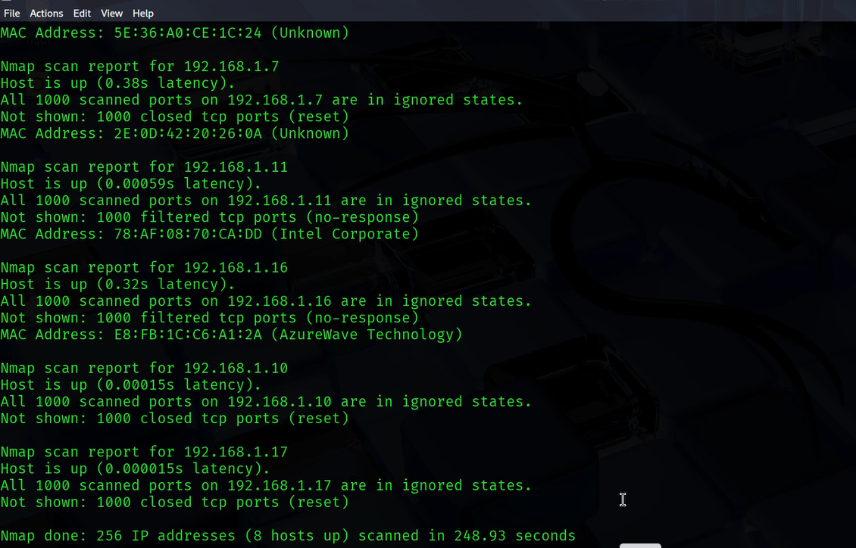

**Step-4:**

Detecting services and ports of IP address using command

**“nmap -sV 192.168.1.10/24”**

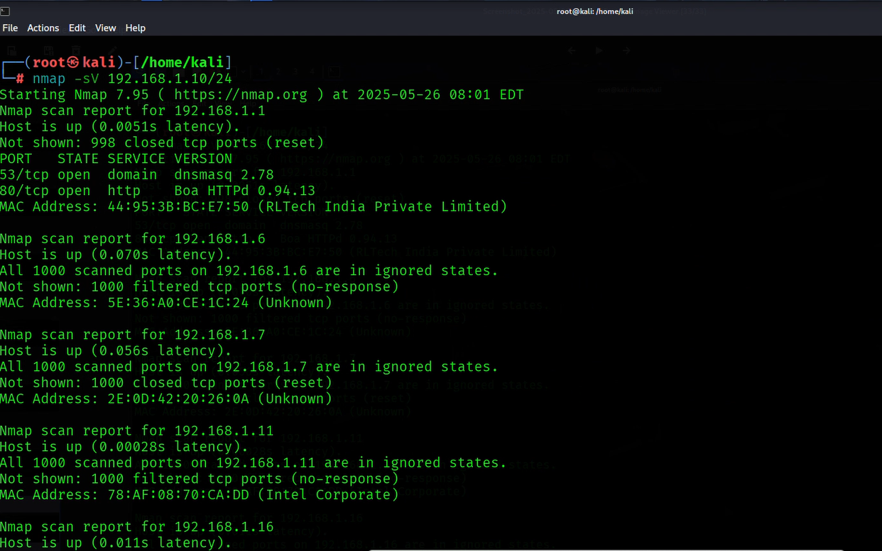

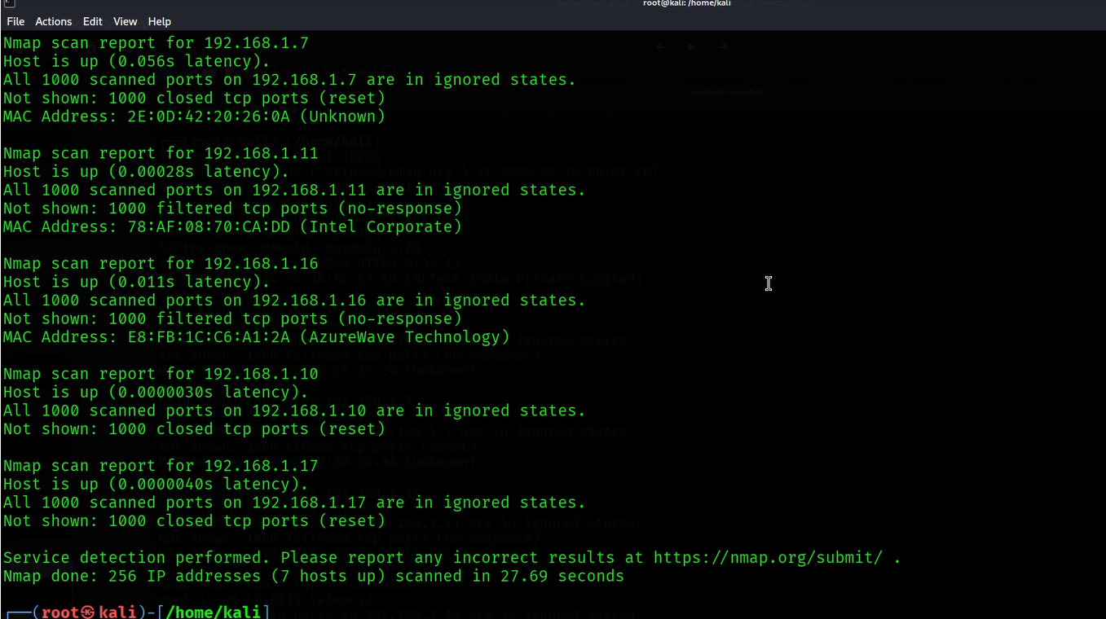

**Step-5:**

Saving Scan results in to a file using command

**“sudo nmap -sS 192.168.1.10/24 -oN scan_results.txt”**

